V6Z80P + V1.1b

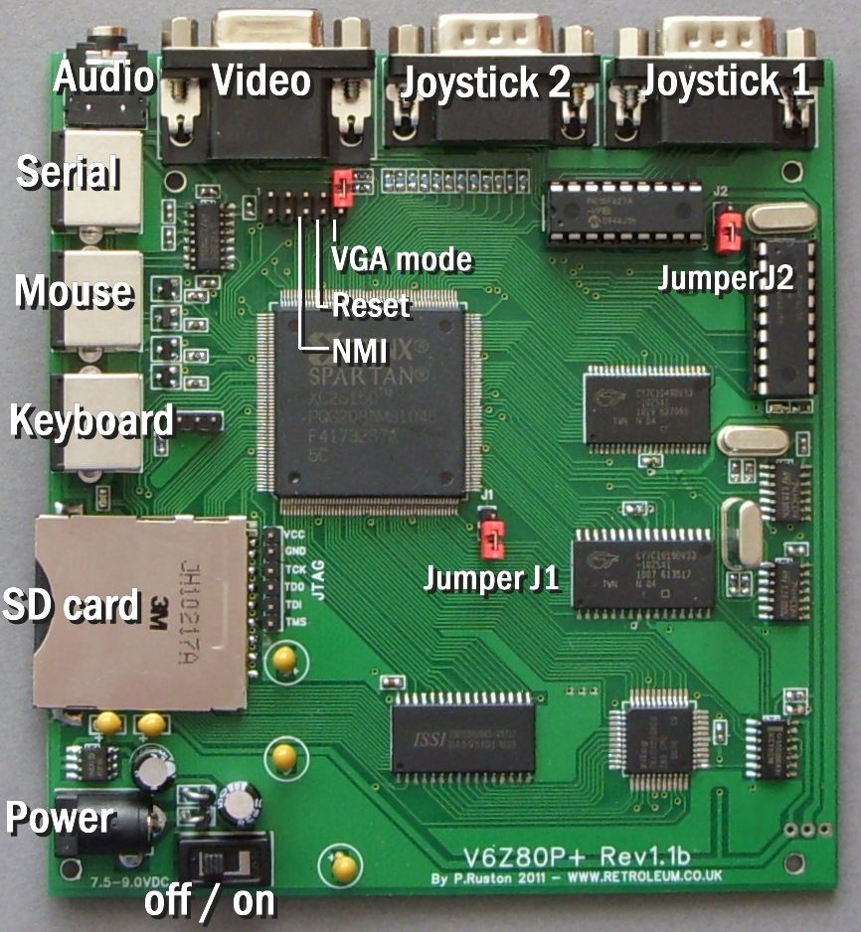

For the complete project archive / latest full documentation please visit:

wiki.retroleum.co.uk
Getting started - Basic Info

Basics:

The V6Z80P system - as supplied - comprises of 3 main elements:

1. The PCB itself, this is the actual "V6Z80P”

2. My default FPGA architecture design for the FPGA called "OSCA" (Old School Computer Architecture) held in the onboard EEPROM

3. My command line operating system called "FLOS" (Freezer-Like Operating System) held in the EEPROM and / or on SD card.

The V6Z80P requires a 7.5 volt (or 9 volt maximum) DC regulated mains adapter capable of delivering about 800mA or more. The jack plug should be 2.1mm type, centre-pin positive.
Before powering up:

At a minimum, connect power, PS/2 keyboard, video/audio cables, make sure the VGA-mode jumper (on the 10 pin header) is installed if using a PC monitor. The JTAG jumpers (J1 and J2) should be uninstalled for normal EEPROM-based start-up.

Download the full project archive from the wiki address above (to PC) then format an MMC, SD or SDHC card to FAT16 (please use a good brand to ensure compatibility - in case of problems formatting to FAT16 try formatting the card in the V6Z80P with the FLOS command “FORMAT SD_CARD”). Copy the contents of the folder "V6_SD_Card" from the project archive to the card and insert it into the V6Z80P's card slot. (You can use the V6Z80P without an SD card, but you'll need to download everything serially except the internal commands via serial comms).

Power on the V6Z80P with the switch near the DC power socket. The orange LED should come on, the black and white boot-up display appears on screen and afterwards the OS loads (from SD card if present, or failing that, from the onboard EEPROM). Once loaded, you can type "?" <return> for a list of internal commands.

Programs can be run from the SD card (use the command line to navigate in a similar manner to DOS) or downloaded into memory via serial comms from a Windows PC using the serial_link cable and utility provided (see the "PC_based_apps" folder in project archive). Most of the demos etc can be quit by pressing the ESC key.

Alternative configs:

The onboard EEPROM can store multiple FPGA configurations - on power-up the FPGA starts from whichever is the "Active Slot". As supplied, OSCA for 50Hz PAL TVs (or VGA monitors) is in Slot 1, OSCA for 60Hz NTSC TVs (or VGA monitors) is in Slot2. Alessandro Dorigatti’s cycle-perfect Spectrum 48 Emulator is in slot 3. My “inexact” Spectrum 128 emulator is in Slots 4 (PAL) and 5 (NTSC). (Slot 1 or Slot 2 will be the default Active Slot depending on the location the board was dispatched to.)

The OSCA / FLOS Bootloader allows you switch to one of the other slots by tapping F1-F7 as the system starts up. You can also use the FLOS command "BOOT" or the "EEPROM" configuration utility to reconfigure the FPGA. Note: The cycle-pefect Spectrum 48 emulator needs to be started with the FLOS command: GOSPEC

Notes:

For stability, avoid connecting or disconnecting anything to the V6Z80P whilst the power is switched on.

FLOS cannot automatically recognize card swaps so any card inserted whilst the power is on needs to be initialized with the "MOUNT" command.

If your PC doesn't have a (free) serial port, a USB->RS232 cable/adapter should work. Occasionally, the first file transfer may fail with a "bad acknowledge" report. I’ve never found out why!

